**CO2 PROGRAM**

1. Design a registration activity and store registration details in local memory of phone using Intents and SharedPreferences

Xml

*<?*xml version="1.0" encoding="utf-8"*?>*<androidx.constraintlayout.widget.ConstraintLayout xmlns:android="http://schemas.android.com/apk/res/android"  
 xmlns:app="http://schemas.android.com/apk/res-auto"  
 xmlns:tools="http://schemas.android.com/tools"  
 android:layout_width="match_parent"  
 android:layout_height="match_parent"  
 tools:context=".MainActivity">  
  
 <LinearLayout  
 android:layout_width="match_parent"  
 android:layout_height="match_parent"  
 android:orientation="vertical">  
  
 <EditText  
 android:id="@+id/Et_name"  
 android:layout_width="match_parent"  
 android:layout_height="wrap_content"  
 android:ems="10"  
 android:inputType="textPersonName"  
 android:text="Name" />  
  
 <EditText  
 android:id="@+id/Et_pswd"  
 android:layout_width="match_parent"  
 android:layout_height="wrap_content"  
 android:ems="10"  
 android:inputType="textPersonName"  
 android:text="Password" />  
  
 <Button  
 android:id="@+id/b1"  
 android:layout_width="match_parent"  
 android:layout_height="wrap_content"  
 android:onClick="onClick"  
 android:text="Button" />  
 </LinearLayout>  
</androidx.constraintlayout.widget.ConstraintLayout>

Xml2

*<?*xml version="1.0" encoding="utf-8"*?>*<androidx.constraintlayout.widget.ConstraintLayout xmlns:android="http://schemas.android.com/apk/res/android"  
 xmlns:app="http://schemas.android.com/apk/res-auto"  
 xmlns:tools="http://schemas.android.com/tools"  
 android:layout_width="match_parent"  
 android:layout_height="match_parent"  
 tools:context=".MainActivity2">  
  
 <LinearLayout  
 android:layout_width="match_parent"  
 android:layout_height="match_parent"  
 android:orientation="vertical">  
  
 <TextView  
 android:id="@+id/t1"  
 android:layout_width="match_parent"  
 android:layout_height="wrap_content"  
 android:text="TextView" />  
  
 <TextView  
 android:id="@+id/t2"  
 android:layout_width="match_parent"  
 android:layout_height="wrap_content"  
 android:text="TextView" />  
 </LinearLayout>  
</androidx.constraintlayout.widget.ConstraintLayout>

Java

package com.example.sharedpref;  
  
import androidx.appcompat.app.AppCompatActivity;  
  
import android.content.SharedPreferences;  
import android.os.Bundle;  
import android.widget.TextView;  
  
public class MainActivity2 extends AppCompatActivity {  
 TextView T1,T2;  
 SharedPreferences sp;  
  
  
 @Override  
 protected void onCreate(Bundle savedInstanceState) {  
 super.onCreate(savedInstanceState);  
 setContentView(R.layout.*activity_main2*);  
 T1=findViewById(R.id.*t1*);  
 T2=findViewById(R.id.*t2*);  
 sp=getSharedPreferences("Login",*MODE_PRIVATE*);  
 String Ed1=sp.getString("Username","ABC");  
 String Ed2=sp.getString("Password","123");  
 T1.setText(Ed1);  
 T2.setText(Ed2);  
  
 }  
}

Output

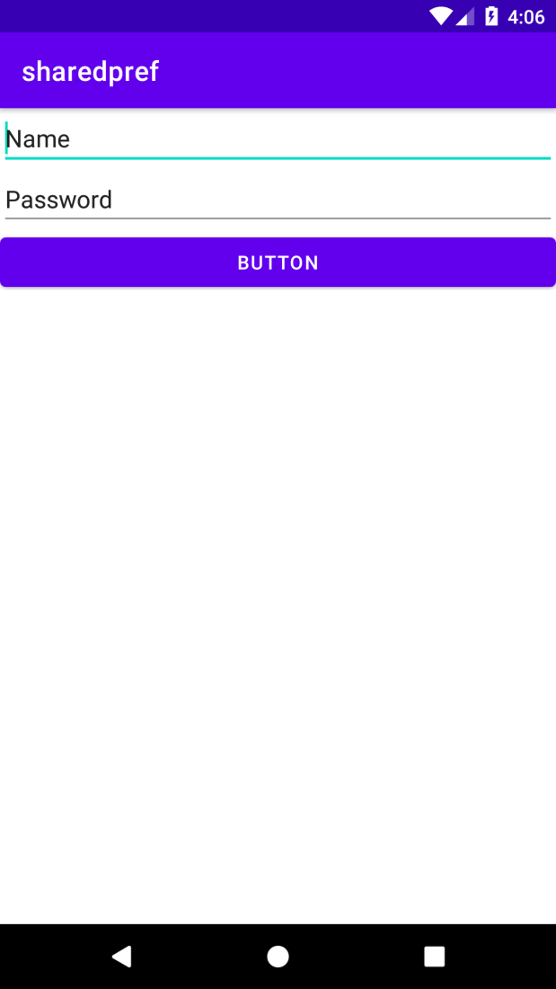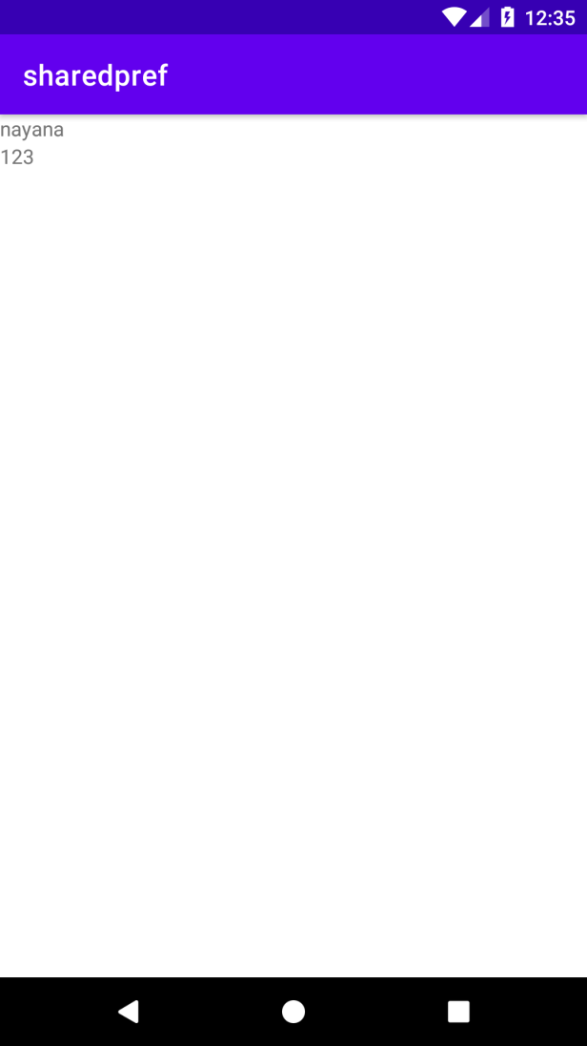

1. Design a simple Calculator using GridLayout and Cascaded LinearLayout

Xml

*<?*xml version="1.0" encoding="utf-8"*?>*<LinearLayout xmlns:android="http://schemas.android.com/apk/res/android"  
 xmlns:app="http://schemas.android.com/apk/res-auto"  
 xmlns:tools="http://schemas.android.com/tools"  
 android:layout_width="match_parent"  
 android:layout_height="match_parent"  
 android:orientation="vertical"  
 tools:context=".MainActivity">  
  
  
 <TextView  
 android:id="@+id/textView"  
 android:layout_width="match_parent"  
 android:layout_height="40dp"  
 android:layout_marginTop="5dp"  
 android:background="#2247FF"  
 android:gravity="center"  
 android:text="WELCOME"  
 android:textColor="#0E0E0D" />  
  
 <EditText  
 android:id="@+id/display"  
 android:layout_marginTop="30dp"  
 android:layout_width="390dp"  
 android:layout_gravity="center"  
 android:layout_height="80dp"  
 android:gravity="center"  
 android:hint="Result"  
 android:inputType="textPersonName"  
 />  
  
 <androidx.gridlayout.widget.GridLayout  
 android:layout_width="wrap_content"  
 android:layout_height="wrap_content"  
 android:layout_marginTop="30dp"  
 android:layout_gravity="center"  
 tools:ignore="MissingClass">  
  
 <Button  
 android:id="@+id/b7"  
 android:layout_width="wrap_content"  
 android:layout_height="54dp"  
 android:backgroundTint="#6e7778"  
 android:text="7"  
 app:layout_column="0"  
 app:layout_row="0" />  
  
 <Button  
 android:id="@+id/b8"  
 android:layout_width="wrap_content"  
 android:layout_height="54dp"  
 android:layout_marginLeft="10dp"  
 android:backgroundTint="#6e7778"  
 android:text="8"  
 app:layout_column="1"  
 app:layout_row="0" />  
  
 <Button  
 android:id="@+id/b9"  
 android:layout_width="wrap_content"  
 android:layout_height="54dp"  
 android:layout_marginLeft="10dp"  
 android:backgroundTint="#6e7778"  
 android:text="9"  
 app:layout_column="2"  
 app:layout_row="0" />  
  
 <Button  
 android:id="@+id/div"  
 android:layout_width="wrap_content"  
 android:layout_height="54dp"  
 android:layout_marginLeft="10dp"  
 android:backgroundTint="#3C393B"  
 android:text="/"  
 app:layout_column="3"  
 app:layout_row="0" />  
  
 <Button  
 android:id="@+id/b4"  
 android:layout_width="wrap_content"  
 android:layout_height="54dp"  
 android:backgroundTint="#6e7778"  
 android:text="4"  
 app:layout_column="0"  
 app:layout_row="1" />  
  
 <Button  
 android:id="@+id/b5"  
 android:layout_width="wrap_content"  
 android:layout_height="54dp"  
 android:layout_marginLeft="10dp"  
 android:backgroundTint="#6e7778"  
 android:text="5"  
 app:layout_column="1"  
 app:layout_row="1" />  
  
 <Button  
 android:id="@+id/b6"  
 android:layout_width="wrap_content"  
 android:layout_height="54dp"  
 android:layout_marginLeft="10dp"  
 android:backgroundTint="#6e7778"  
 android:text="6"  
 app:layout_column="2"  
 app:layout_row="1" />  
  
 <Button  
 android:id="@+id/mul"  
 android:layout_width="wrap_content"  
 android:layout_height="54dp"  
 android:layout_marginLeft="10dp"  
 android:backgroundTint="#3C393B"  
 android:text="x"  
 app:layout_column="3"  
 app:layout_row="1" />  
  
 <Button  
 android:id="@+id/b1"  
 android:layout_width="wrap_content"  
 android:layout_height="54dp"  
 android:backgroundTint="#6e7778"  
 android:text="1"  
 app:layout_column="0"  
 app:layout_row="2" />  
  
 <Button  
 android:id="@+id/b2"  
 android:layout_width="wrap_content"  
 android:layout_height="54dp"  
 android:layout_marginLeft="10dp"  
 android:backgroundTint="#6e7778"  
 android:text="2"  
 app:layout_column="1"  
 app:layout_row="2" />  
  
 <Button  
 android:id="@+id/b3"  
 android:layout_width="wrap_content"  
 android:layout_height="54dp"  
 android:layout_marginLeft="10dp"  
 android:backgroundTint="#6e7778"  
 android:text="3"  
 app:layout_column="2"  
 app:layout_row="2" />  
  
 <Button  
 android:id="@+id/sub"  
 android:layout_width="wrap_content"  
 android:layout_height="54dp"  
 android:layout_marginLeft="10dp"  
 android:backgroundTint="#3C393B"  
 android:text="-"  
 app:layout_column="3"  
 app:layout_row="2" />  
  
 <Button  
 android:id="@+id/clr"  
 android:layout_width="wrap_content"  
 android:layout_height="54dp"  
 android:backgroundTint="#3C393B"  
 android:text="clr"  
 app:layout_column="0"  
 app:layout_row="3" />  
  
 <Button  
 android:id="@+id/b0"  
 android:layout_width="wrap_content"  
 android:layout_height="54dp"  
 android:layout_marginLeft="10dp"  
 android:backgroundTint="#6e7778"  
 android:text="0"  
 app:layout_column="1"  
 app:layout_row="3" />  
  
 <Button  
 android:id="@+id/equal"  
 android:layout_width="wrap_content"  
 android:layout_height="54dp"  
 android:layout_marginLeft="10dp"  
 android:backgroundTint="#3C393B"  
 android:text="="  
 app:layout_column="2"  
 app:layout_row="3" />  
  
 <Button  
 android:id="@+id/add"  
 android:layout_width="wrap_content"  
 android:layout_height="54dp"  
 android:layout_marginLeft="10dp"  
 android:backgroundTint="#3C393B"  
 android:text="+"  
 app:layout_column="3"  
 app:layout_row="3" />  
 </androidx.gridlayout.widget.GridLayout>  
  
</LinearLayout>

Java

package com.example.grid;  
  
 import androidx.appcompat.app.AppCompatActivity;  
  
 import android.os.Bundle;  
 import android.view.View;  
 import android.widget.Button;  
 import android.widget.EditText;  
  
  
public class MainActivity extends AppCompatActivity implements View.OnClickListener {  
  
  
 EditText number;  
 double num1=0;  
 double num2=0;  
 String op="";  
 Button b1, b2, b3, b4, b5, b6, b7, b8, b9, b0, sum, sub, mul, div,equal, clear;  
  
  
 @Override  
 protected void onCreate(Bundle savedInstanceState) {  
 super.onCreate(savedInstanceState);  
 setContentView(R.layout.*activity_main*);  
  
 number = findViewById(R.id.*display*);  
 b0 = findViewById(R.id.*b0*);  
 b1 = findViewById(R.id.*b1*);  
 b2 = findViewById(R.id.*b2*);  
 b3 = findViewById(R.id.*b3*);  
 b4 = findViewById(R.id.*b4*);  
 b5 = findViewById(R.id.*b5*);  
 b6 = findViewById(R.id.*b6*);  
 b7 = findViewById(R.id.*b7*);  
 b8 = findViewById(R.id.*b8*);  
 b9 = findViewById(R.id.*b9*);  
  
 sum = findViewById(R.id.*add*);  
 sub = findViewById(R.id.*sub*);  
 mul = findViewById(R.id.*mul*);  
 div = findViewById(R.id.*div*);  
  
 equal = findViewById(R.id.*equal*);  
 clear = findViewById(R.id.*clr*);  
  
 b0.setOnClickListener(this);  
 b1.setOnClickListener(this);  
 b2.setOnClickListener(this);  
 b3.setOnClickListener(this);  
 b4.setOnClickListener(this);  
 b5.setOnClickListener(this);  
 b6.setOnClickListener(this);  
 b7.setOnClickListener(this);  
 b8.setOnClickListener(this);  
 b9.setOnClickListener(this);  
  
 mul.setOnClickListener(this);  
 div.setOnClickListener(this);  
  
  
 sub.setOnClickListener(this);  
 sum.setOnClickListener(this);  
 clear.setOnClickListener(this);  
 equal.setOnClickListener(this);  
 }  
  
 @Override  
 public void onClick(View view) {  
 Button b= (Button) view;  
 if(view==clear)  
 {  
 number.setText("");  
 }  
  
 else if(view==sub||view==sum||view==mul||view==div)  
 {  
 num1=Integer.*parseInt*(number.getText().toString());  
 op=b.getText().toString();  
 number.setText("");  
 }  
  
 else if(view==equal)  
 {  
 num2=Integer.*parseInt*(number.getText().toString());  
 if(op.equals("+"))  
 {  
 number.setText(num1+num2+"");  
 }  
 else if(op.equals("-"))  
 {  
 number.setText(num1-num2+"");  
 }  
 else if(op.equals("x"))  
 {  
 number.setText(num1*num2+"");  
 }  
 else if(op.equals("/"))  
 {  
 number.setText(num1/num2+"");  
 }  
 }  
 else  
 {  
 String s=number.getText().toString();  
 number.setText(s+b.getText().toString());  
 }  
 }  
  
  
}

Output

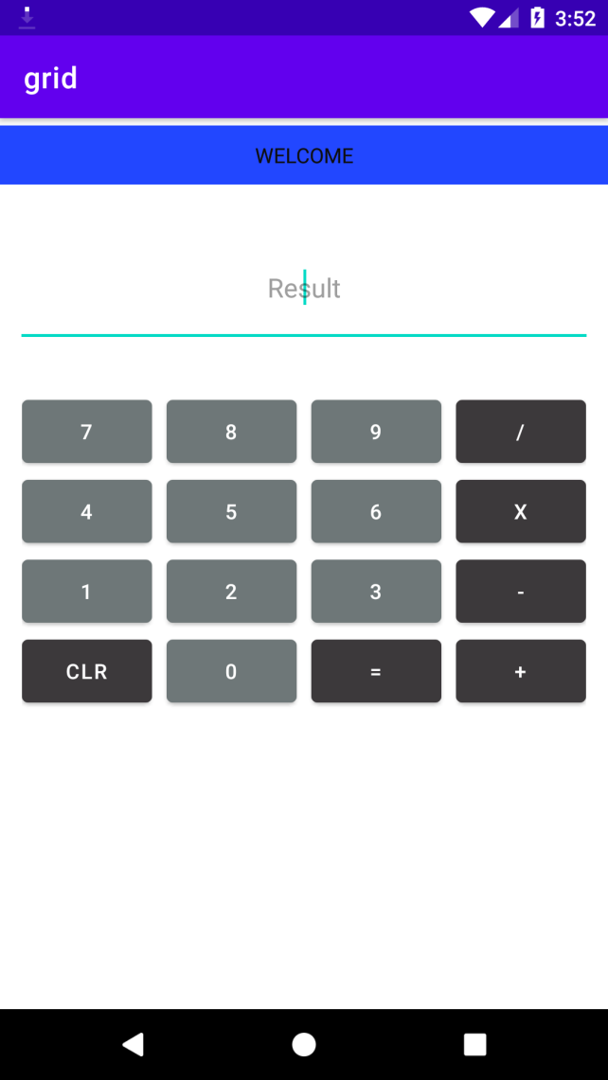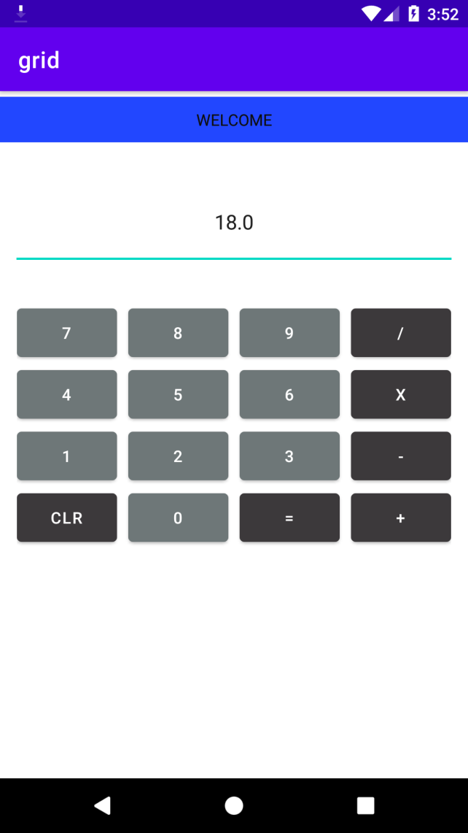

1. Create a Facebook page using RelativeLayout; set properties using .xml file

Xml

*<?*xml version="1.0" encoding="utf-8"*?>*<RelativeLayout xmlns:android="http://schemas.android.com/apk/res/android"  
 xmlns:app="http://schemas.android.com/apk/res-auto"  
 xmlns:tools="http://schemas.android.com/tools"  
 android:layout_width="match_parent"  
 android:layout_height="match_parent"  
 android:background="#2196F3"  
 tools:context=".MainActivity">  
  
 <ImageView  
 android:id="@+id/imageView"  
 android:layout_width="196dp"  
 android:layout_height="209dp"  
 android:layout_centerHorizontal="true"  
 android:layout_marginTop="100dp"  
 app:srcCompat="@drawable/f" />  
  
 <EditText  
 android:id="@+id/edit"  
 android:layout_width="match_parent"  
 android:layout_height="wrap_content"  
 android:layout_below="@id/imageView"  
 android:layout_marginTop="50dp"  
 android:ems="10"  
 android:inputType="textPersonName"  
 android:text="Username or email" />  
  
 <EditText  
 android:id="@+id/edit2"  
 android:layout_width="match_parent"  
 android:layout_height="wrap_content"  
 android:layout_below="@id/edit"  
 android:layout_marginTop="20dp"  
 android:ems="10"  
 android:inputType="textPersonName"  
 android:text="password" />  
  
 <Button  
 android:id="@+id/button"  
 android:layout_width="209dp"  
 android:layout_height="wrap_content"  
 android:layout_below="@id/edit2"  
 android:layout_centerHorizontal="true"  
 android:layout_marginTop="0dp"  
 android:backgroundTint="#3F51B5"  
 android:text="LOGIN" />  
</RelativeLayout>

Java

package com.example.fbbblogo;  
  
import androidx.appcompat.app.AppCompatActivity;  
  
import android.os.Bundle;  
  
public class MainActivity extends AppCompatActivity {  
  
 @Override  
 protected void onCreate(Bundle savedInstanceState) {  
 super.onCreate(savedInstanceState);  
 setContentView(R.layout.*activity_main*);  
 }  
}

Output

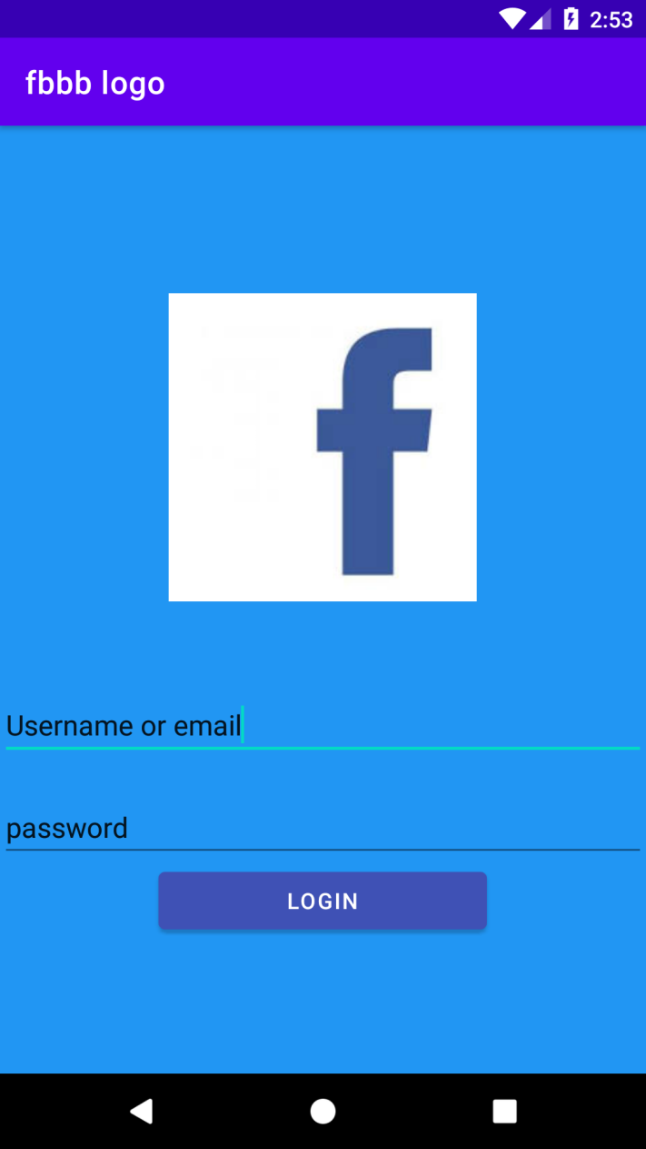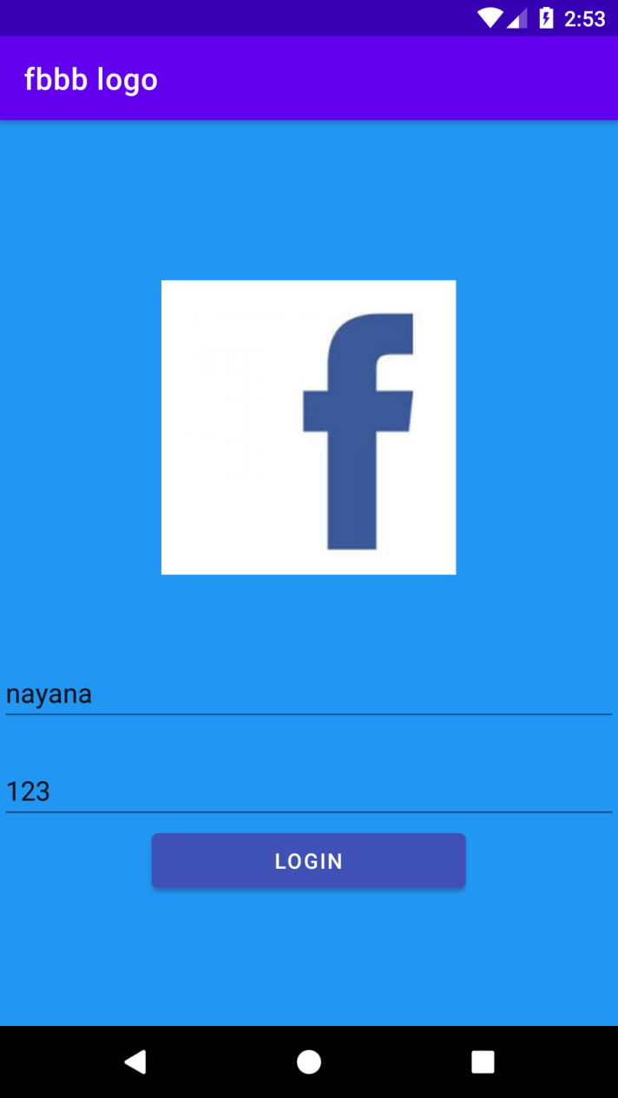

1. Develop an application that toggles image using Frame Layout

Xml

*<?*xml version="1.0" encoding="utf-8"*?>*<FrameLayout xmlns:android="http://schemas.android.com/apk/res/android"  
 xmlns:app="http://schemas.android.com/apk/res-auto"  
 xmlns:tools="http://schemas.android.com/tools"  
 android:layout_width="match_parent"  
 android:layout_height="match_parent"  
 tools:context=".MainActivity">  
  
 <LinearLayout  
 android:layout_width="match_parent"  
 android:layout_height="match_parent"  
 android:orientation="horizontal">  
  
 <ImageButton  
 android:id="@+id/im3"  
 android:layout_width="161dp"  
 android:layout_height="374dp"  
 android:layout_weight="1"  
 android:src="@drawable/flower"  
 />  
  
 <ImageButton  
 android:id="@+id/im4"  
 android:layout_width="113dp"  
 android:layout_height="396dp"  
 android:layout_weight="1"  
 android:src="@drawable/fr"  
 />  
 </LinearLayout>  
</FrameLayout>

Java

package com.example.fame;  
  
import androidx.appcompat.app.AppCompatActivity;  
  
import android.os.Bundle;  
import android.view.View;  
import android.widget.ImageView;  
  
public class MainActivity extends AppCompatActivity implements View.OnClickListener {  
 ImageView img1,img2;  
  
 @Override  
 protected void onCreate(Bundle savedInstanceState) {  
 super.onCreate(savedInstanceState);  
 setContentView(R.layout.*activity_main*);  
 img1=(ImageView) findViewById(R.id.*im3*);  
 img2=(ImageView) findViewById(R.id.*im4*);  
 img1.setOnClickListener(this);  
 img2.setOnClickListener(this);  
  
 }  
  
 public void onClick(View view) {  
 if(view == img1)  
 {  
 img1.setVisibility(View.*GONE*);  
 img2.setVisibility(View.*VISIBLE*);  
 }  
 else{  
 img2.setVisibility(View.*GONE*);  
 img1.setVisibility(View.*VISIBLE*);  
 }  
  
 }  
  
  
}

Output

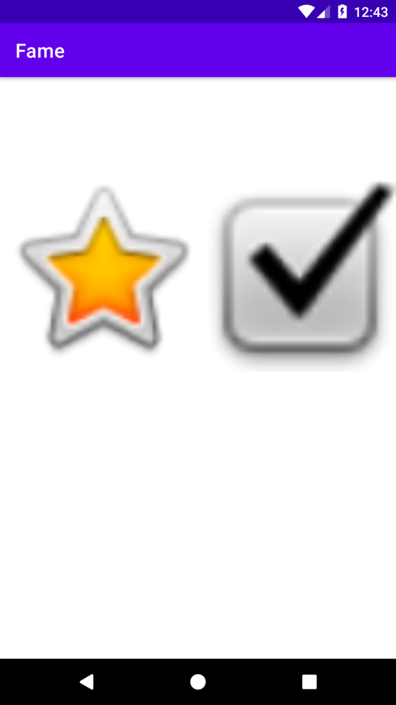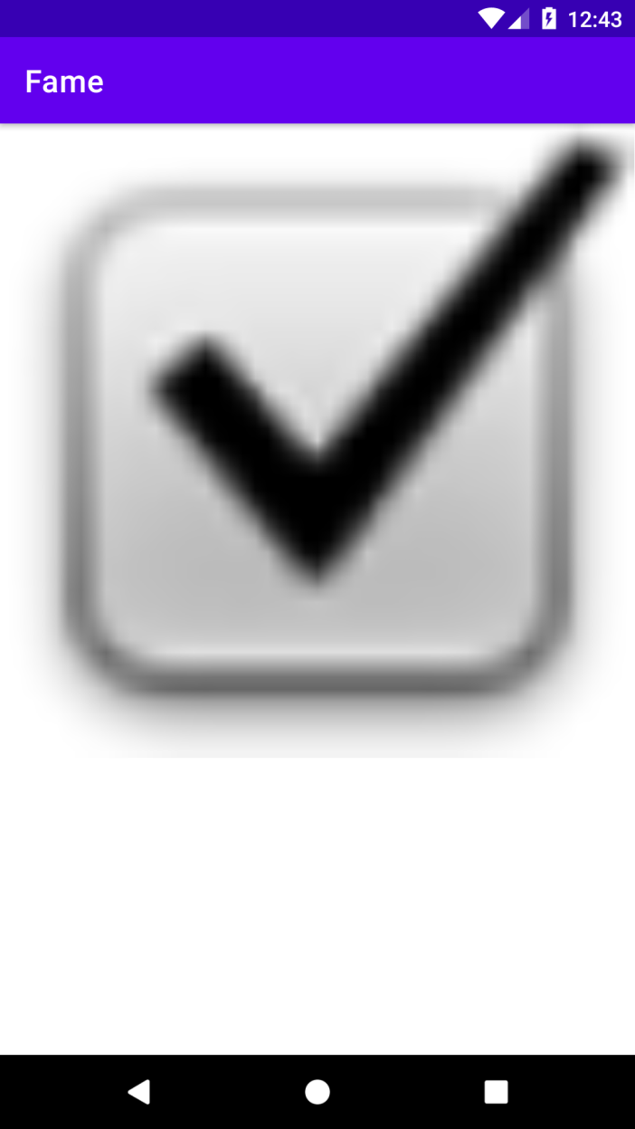

**CO3 PROGRAM**

1. Implement Adapters and perform exception handling

2. Implement Intent to navigate between multiple activities

Xml

*<?*xml version="1.0" encoding="utf-8"*?>*<androidx.constraintlayout.widget.ConstraintLayout xmlns:android="http://schemas.android.com/apk/res/android"  
 xmlns:app="http://schemas.android.com/apk/res-auto"  
 xmlns:tools="http://schemas.android.com/tools"  
 android:layout_width="match_parent"  
 android:layout_height="match_parent"  
 tools:context=".MainActivity">  
  
 <LinearLayout  
 android:layout_width="match_parent"  
 android:layout_height="match_parent"  
 android:orientation="horizontal"  
 tools:layout_editor_absoluteX="16dp"  
 tools:layout_editor_absoluteY="-145dp">  
  
 <EditText  
 android:id="@+id/ET_name"  
 android:layout_width="wrap_content"  
 android:layout_height="wrap_content"  
 android:ems="10"  
 android:inputType="textPersonName"  
 android:minHeight="48dp"  
 tools:ignore="SpeakableTextPresentCheck" />  
  
 <Button  
 android:id="@+id/b1"  
 android:layout_width="wrap_content"  
 android:layout_height="wrap_content"  
 android:onClick="onclick"  
 android:text="Button" />  
  
 </LinearLayout>  
  
</androidx.constraintlayout.widget.ConstraintLayout>

Java

package com.example.co21;  
  
import androidx.appcompat.app.AppCompatActivity;  
  
import android.content.Intent;  
import android.os.Bundle;  
import android.view.View;  
import android.widget.EditText;  
  
public class MainActivity extends AppCompatActivity {  
  
 EditText edname;  
  
  
  
 @Override  
 protected void onCreate(Bundle savedInstanceState) {  
 super.onCreate(savedInstanceState);  
 setContentView(R.layout.*activity_main*);  
  
  
 edname = findViewById(R.id.*ET_name*);  
  
 }  
  
 public void onclick(View view){  
 Intent i = new Intent(MainActivity.this,MainActivity2.class);  
 String val_1=edname.getText().toString();  
 Bundle b=new Bundle();  
 b.putString("Name",val_1);  
 i.putExtras(b);  
 startActivity(i);  
 }  
  
  
}

Xml2

*<?*xml version="1.0" encoding="utf-8"*?>*<androidx.constraintlayout.widget.ConstraintLayout xmlns:android="http://schemas.android.com/apk/res/android"  
 xmlns:app="http://schemas.android.com/apk/res-auto"  
 xmlns:tools="http://schemas.android.com/tools"  
 android:layout_width="match_parent"  
 android:layout_height="match_parent"  
 tools:context=".MainActivity2" >  
  
 <LinearLayout  
 android:layout_width="match_parent"  
 android:layout_height="match_parent"  
 android:orientation="vertical"></LinearLayout>  
  
 <EditText  
 android:id="@+id/Et_text"  
 android:layout_width="wrap_content"  
 android:layout_height="wrap_content"  
 android:ems="10"  
 android:inputType="textPersonName"  
 tools:layout_editor_absoluteX="16dp"  
 tools:layout_editor_absoluteY="49dp" />  
</androidx.constraintlayout.widget.ConstraintLayout>

Java2

package com.example.co21;  
  
import androidx.appcompat.app.AppCompatActivity;  
  
import android.content.Intent;  
import android.os.Bundle;  
import android.widget.EditText;  
import android.widget.Toast;  
  
public class MainActivity2 extends AppCompatActivity {  
  
 EditText ET_name;  
  
 @Override  
 protected void onCreate(Bundle savedInstanceState) {  
 super.onCreate(savedInstanceState);  
 setContentView(R.layout.*activity_main2*);  
 ET_name=findViewById(R.id.*Et_text*);  
  
 Toast.*makeText*(this,"welcome",Toast.*LENGTH_SHORT*).show();  
  
 Bundle extras=getIntent().getExtras();  
 String v1 = extras.getString("Name");  
 ET_name.setText(v1+"");  
  
  
  
 }  
}

Output

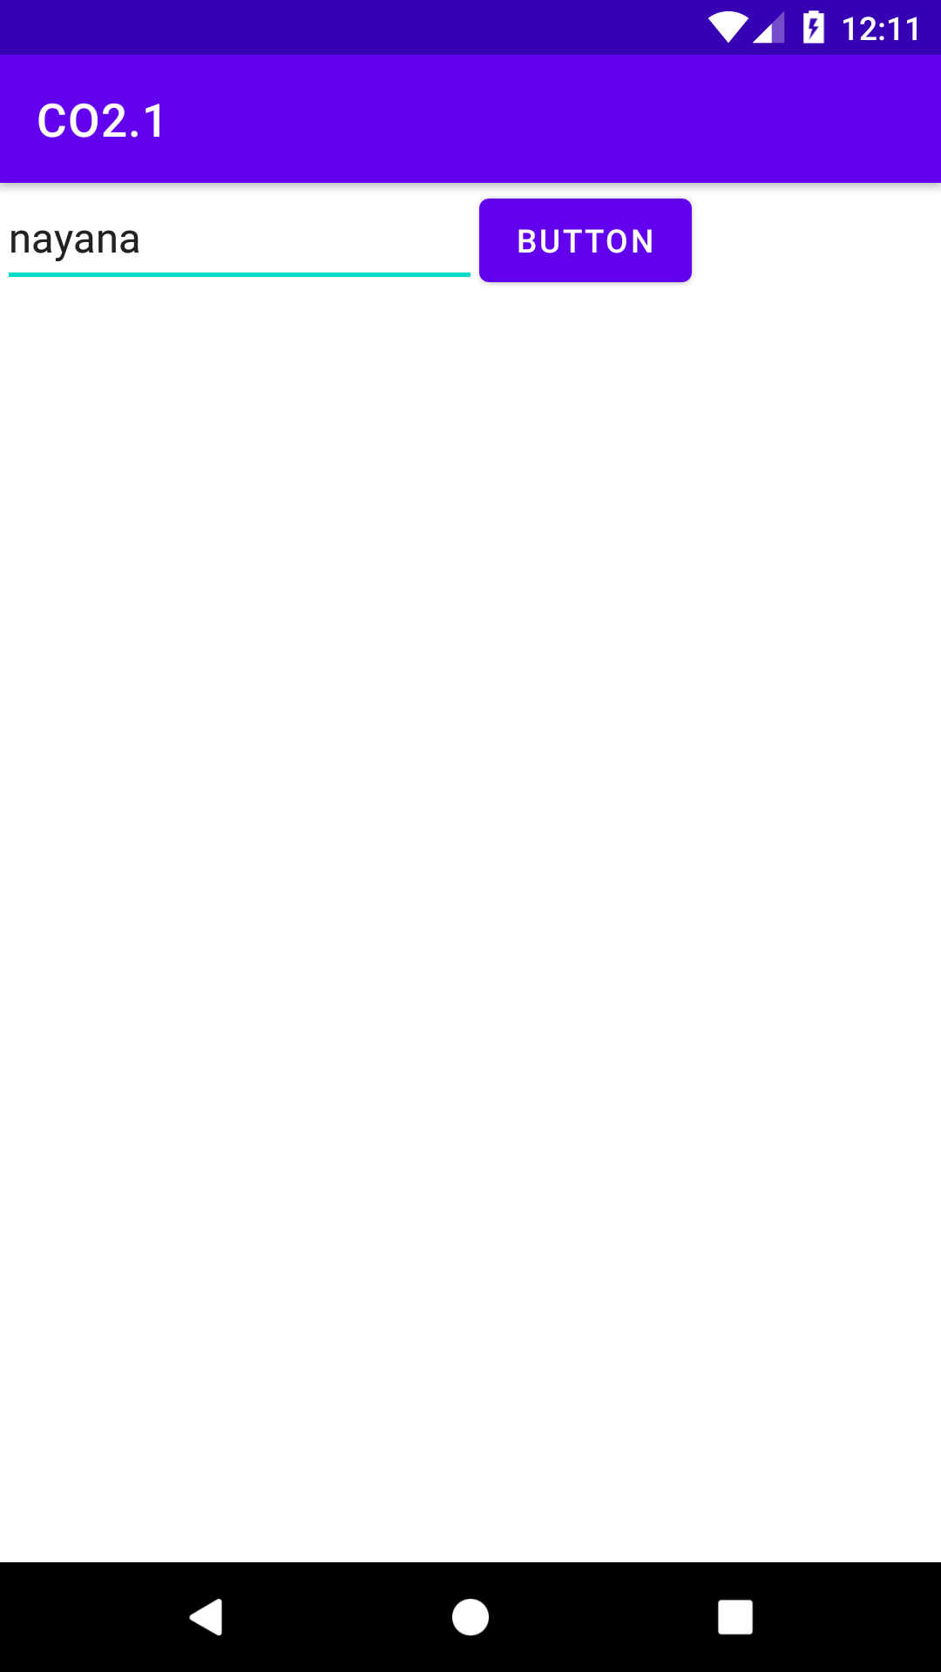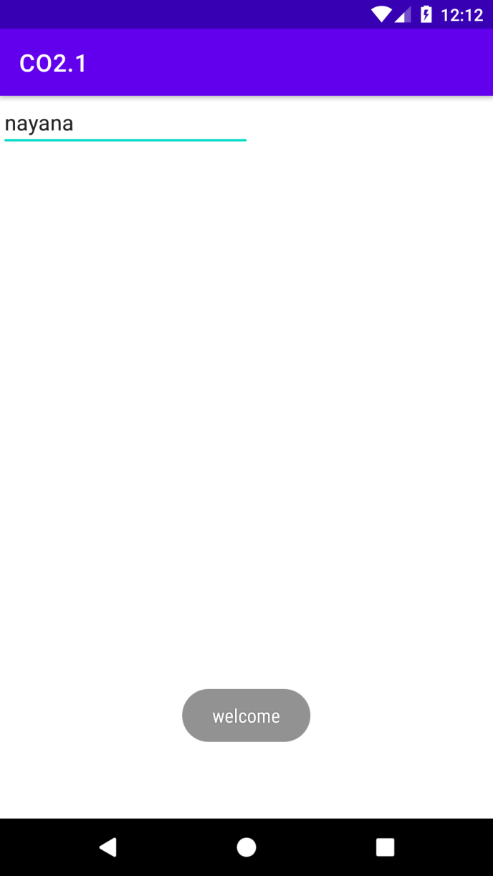

3. Develop application that works with explicit intents

4. Implement Options Menu to navigate to activities

Xml

*<?*xml version="1.0" encoding="utf-8"*?>*<androidx.constraintlayout.widget.ConstraintLayout xmlns:android="http://schemas.android.com/apk/res/android"  
 xmlns:app="http://schemas.android.com/apk/res-auto"  
 xmlns:tools="http://schemas.android.com/tools"  
 android:layout_width="match_parent"  
 android:layout_height="match_parent"  
 tools:context=".MainActivity"/>

Samplemenu.xml

*<?*xml version="1.0" encoding="utf-8"*?>*<menu xmlns:tools="http://schemas.android.com/tools"  
 xmlns:app="http://schemas.android.com/apk/res-auto"  
 xmlns:android="http://schemas.android.com/apk/res/android">  
 <item  
 android:id="@+id/item1"  
 android:title="Item">  
 <menu>  
 <item  
 android:id="@+id/m1"  
 android:title="sub1" />  
 <item  
 android:id="@+id/m2"  
 android:title="sub2"/>  
  
 </menu>  
 </item>  
 <item  
 android:id="@+id/item2"  
 android:title="Item" />  
</menu>

Java

package com.example.co3;  
  
import androidx.appcompat.app.AppCompatActivity;  
  
import android.content.Intent;  
import android.os.Bundle;  
import android.view.Menu;  
import android.view.MenuInflater;  
import android.view.MenuItem;  
import android.widget.Toast;  
  
public class MainActivity extends AppCompatActivity {  
  
 @Override  
 protected void onCreate(Bundle savedInstanceState) {  
 super.onCreate(savedInstanceState);  
 setContentView(R.layout.*activity_main*);  
 }  
 public boolean onCreateOptionsMenu(Menu menu){  
 MenuInflater inflater=getMenuInflater();  
 inflater.inflate(R.menu.*samplemenu*,menu);  
 return true;  
  
 }  
 public boolean onOptionsItemSelected(MenuItem item){  
 switch (item.getItemId()){  
 case R.id.*item1*:  
 Intent i=new Intent(this,MainActivity2.class);  
 startActivity(i);  
 break;  
 case R.id.*m1*:  
 Toast.*makeText*(this,"m1",Toast.*LENGTH_SHORT*).show();  
 break;  
 case R.id.*m2*:  
 Intent l=new Intent(this,MainActivity2.class);  
 startActivity(l);  
 break;  
 case R.id.*item2*:  
 Toast.*makeText*(this, "item2", Toast.*LENGTH_SHORT*).show();  
 break;  
  
 }  
 return true;  
 }  
}

Xml2

*<?*xml version="1.0" encoding="utf-8"*?>*<androidx.constraintlayout.widget.ConstraintLayout xmlns:android="http://schemas.android.com/apk/res/android"  
 xmlns:app="http://schemas.android.com/apk/res-auto"  
 xmlns:tools="http://schemas.android.com/tools"  
 android:layout_width="match_parent"  
 android:layout_height="match_parent"  
 tools:context=".MainActivity2">  
  
 <ImageView  
 android:id="@+id/imageView"  
 android:layout_width="405dp"  
 android:layout_height="581dp"  
 app:srcCompat="@drawable/ic_launcher_background"  
 tools:layout_editor_absoluteX="3dp"  
 tools:layout_editor_absoluteY="67dp" />  
</androidx.constraintlayout.widget.ConstraintLayout>

Java2

package com.example.co3;  
  
import androidx.appcompat.app.AppCompatActivity;  
  
import android.os.Bundle;  
  
public class MainActivity2 extends AppCompatActivity {  
  
 @Override  
 protected void onCreate(Bundle savedInstanceState) {  
 super.onCreate(savedInstanceState);  
 setContentView(R.layout.*activity_main2*);  
 }  
}

Output

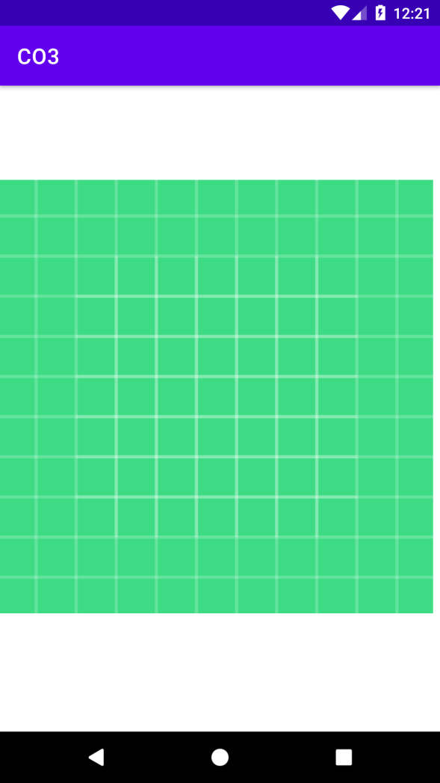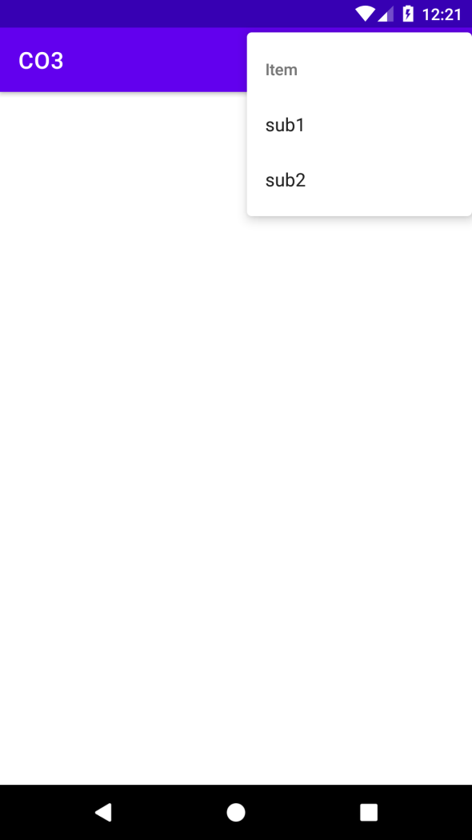

5. Develop an application that uses ArrayAdapter with ListView.

**CO5 PROGRAM**

1. Create database using SQLite and perform INSERT and SELECT . Perform UPDATE and DELETE on SQLite .

Xml

*<?*xml version="1.0" encoding="utf-8"*?>*<androidx.constraintlayout.widget.ConstraintLayout xmlns:android="http://schemas.android.com/apk/res/android"  
 xmlns:app="http://schemas.android.com/apk/res-auto"  
 xmlns:tools="http://schemas.android.com/tools"  
 android:layout_width="match_parent"  
 android:layout_height="match_parent"  
 android:layout_centerHorizontal="true"  
 tools:context=".MainActivity">  
  
 <LinearLayout  
 android:layout_width="match_parent"  
 android:layout_height="match_parent"  
 android:orientation="vertical">  
  
 <EditText  
 android:id="@+id/Ed1"  
 android:layout_width="match_parent"  
 android:layout_height="56dp"  
 android:ems="10"  
 android:inputType="textPersonName"  
 android:text="ID" />  
  
 <EditText  
 android:id="@+id/Ed2"  
 android:layout_width="match_parent"  
 android:layout_height="58dp"  
 android:ems="10"  
 android:inputType="textPersonName"  
 android:text="Name"  
 tools:ignore="TouchTargetSizeCheck" />  
  
 <EditText  
 android:id="@+id/Ed3"  
 android:layout_width="match_parent"  
 android:layout_height="65dp"  
 android:ems="10"  
 android:inputType="textPersonName"  
 android:text="Place"  
 tools:ignore="TouchTargetSizeCheck" />  
  
 <Button  
 android:id="@+id/b1"  
 android:layout_width="match_parent"  
 android:layout_height="wrap_content"  
 android:text="INSERT" />  
  
 <Button  
 android:id="@+id/b2"  
 android:layout_width="match_parent"  
 android:layout_height="wrap_content"  
 android:text="SELECT" />  
  
 <Button  
 android:id="@+id/b3"  
 android:layout_width="match_parent"  
 android:layout_height="wrap_content"  
 android:text="UPDATE" />  
  
 <Button  
 android:id="@+id/b4"  
 android:layout_width="match_parent"  
 android:layout_height="wrap_content"  
 android:text="DELETE" />  
  
 <Button  
 android:id="@+id/b5"  
 android:layout_width="match_parent"  
 android:layout_height="wrap_content"  
 android:text="CLEAR" />  
 </LinearLayout>  
</androidx.constraintlayout.widget.ConstraintLayout>

Java

package com.example.db;  
  
import androidx.appcompat.app.AlertDialog;  
import androidx.appcompat.app.AppCompatActivity;  
  
import android.database.Cursor;  
import android.database.sqlite.SQLiteDatabase;  
import android.os.Bundle;  
import android.view.View;  
import android.widget.Button;  
import android.widget.EditText;  
import android.widget.Toast;  
  
public class MainActivity extends AppCompatActivity {  
  
 EditText E1,E2,E3;  
 Button ins,sel,up,del,clr;  
 SQLiteDatabase db;  
 AlertDialog.Builder builder;  
  
  
 @Override  
 protected void onCreate(Bundle savedInstanceState) {  
 super.onCreate(savedInstanceState);  
 setContentView(R.layout.*activity_main*);  
 E1=(EditText) findViewById(R.id.*Ed1*);  
 E2=(EditText) findViewById(R.id.*Ed2*);  
 E3=(EditText) findViewById(R.id.*Ed3*);  
 ins=(Button) findViewById(R.id.*b1*);  
 sel=(Button) findViewById(R.id.*b2*);  
 up=(Button) findViewById(R.id.*b3*);  
 del=(Button) findViewById(R.id.*b4*);  
 clr=(Button) findViewById(R.id.*b5*);  
 builder=new AlertDialog.Builder(this);  
  
 try {  
 db=openOrCreateDatabase("empdb",*MODE_PRIVATE*,null);  
 db.execSQL("Create table employee(ID integer primary key,Name Text,Place Text)");  
 Toast.*makeText*(getApplicationContext(),"created successfully",Toast.*LENGTH_SHORT*).show();  
 }  
 catch(Exception e)  
 {  
  
 }  
 ins.setOnClickListener(new View.OnClickListener() {  
 @Override  
 public void onClick(View view) {  
 try {  
 db.execSQL("Insert into employee values ("+E1.getText().toString()+",'"+E2.getText().toString()+"','"+E3.getText().toString()+"')");  
 Toast.*makeText*(getApplicationContext(), "Record Inserted Successfully", Toast.*LENGTH_SHORT*).show();  
 }  
 catch (Exception e) {  
 Toast.*makeText*(getApplicationContext(), "Error in Data", Toast.*LENGTH_SHORT*).show();  
 }  
 }  
 });  
 clr.callOnClick();  
 sel.setOnClickListener(new View.OnClickListener() {  
 @Override  
 public void onClick(View view) {  
 Cursor c = db.rawQuery("select * from employee ", null);  
 if (c.getCount() == 0) {  
 Toast.*makeText*(getApplicationContext(), "No such record", Toast.*LENGTH_SHORT*).show();  
 } else {  
  
 StringBuffer b = new StringBuffer();  
 while (c.moveToNext()) {  
 b.append("ID:" + c.getString(0) + "\n");  
 b.append("Name:" + c.getString(1) + "\n");  
 b.append("Place:" + c.getString(2) + "\n");  
  
 }  
 Toast.*makeText*(getApplicationContext(), b.toString(), Toast.*LENGTH_LONG*).show();  
 builder.setMessage(b.toString());  
 AlertDialog alert = builder.create();  
 alert.setTitle("Employee Data");  
 alert.show();  
  
 }  
 }  
 });  
 up.setOnClickListener(new View.OnClickListener() {  
 @Override  
 public void onClick(View view) {  
 db.execSQL("update employee set Name='"+E2.getText().toString()+"',Place='"+E3.getText().toString()+"' where ID="+E1.getText().toString()+"");  
 Toast.*makeText*(getApplicationContext(), "updated....", Toast.*LENGTH_SHORT*).show();  
  
 }  
 });  
 del.setOnClickListener(new View.OnClickListener() {  
 @Override  
 public void onClick(View view) {  
 db.execSQL("delete from employee where id="+E1.getText().toString());  
 Toast.*makeText*(getApplicationContext(), "deleted ", Toast.*LENGTH_SHORT*).show();  
 }  
 });  
 clr.setOnClickListener(new View.OnClickListener() {  
 @Override  
 public void onClick(View view) {  
 E1.setText("");  
 E2.setText("");  
 E3.setText("");  
 }  
 });  
 clr.callOnClick();  
 }  
}

Output

